

Day -3: Easy Programs (31-55)

Name: M. Sahasra
Reg. No.: 192425317
Course Code: CSA0919
Course Name: Programming in Java for Spring Framework
Faculty Name: Dr. Magesh Kumar

31. Find LCM and GCD of N Numbers

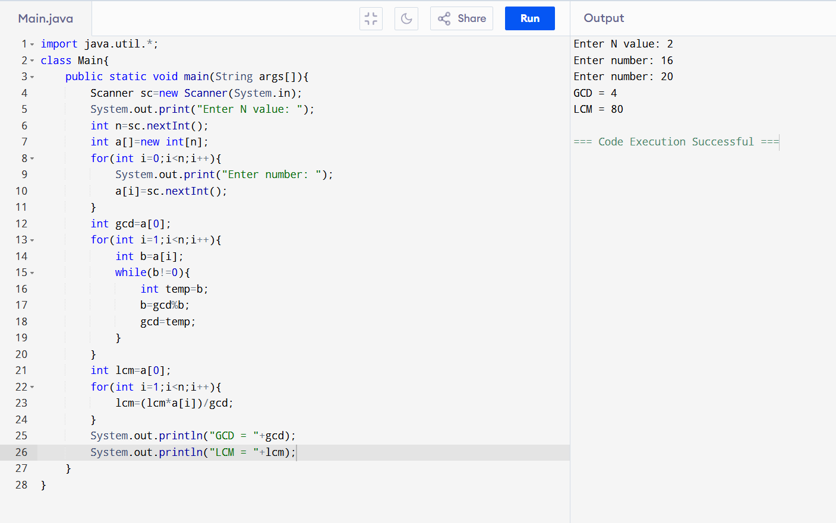

32. Simple Interest Using Function

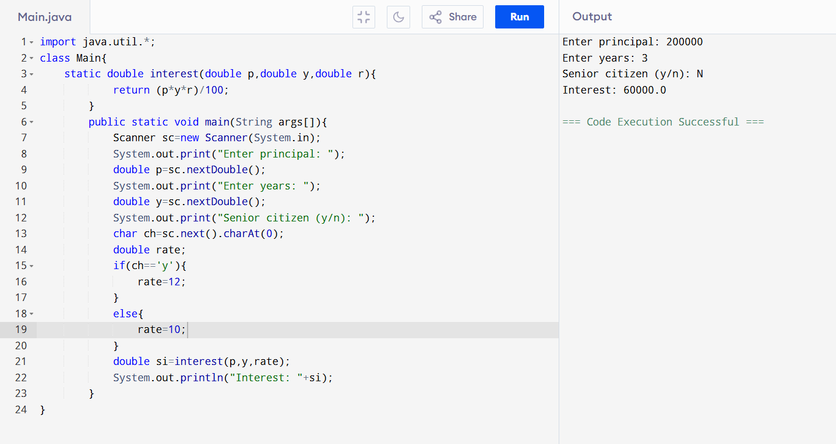

33. Fibonacci Series

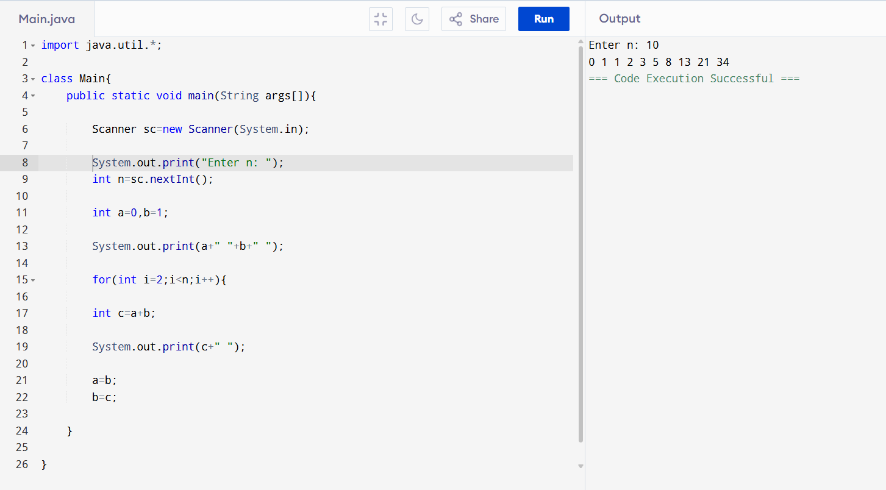

34. Even Index Fibonacci Sum

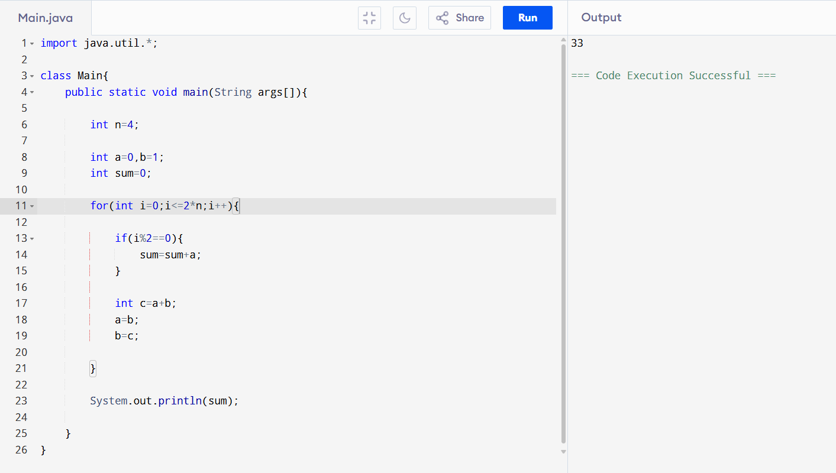

35. Print Numbers from M to N skipping K

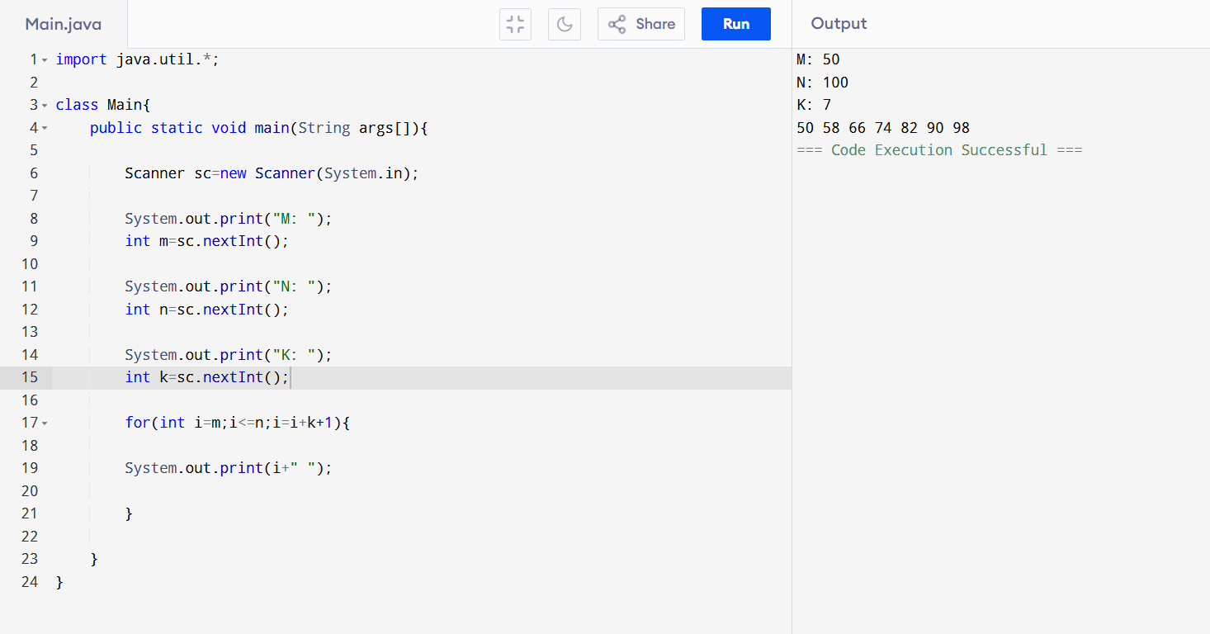

36. Print Composite Numbers Between A and B

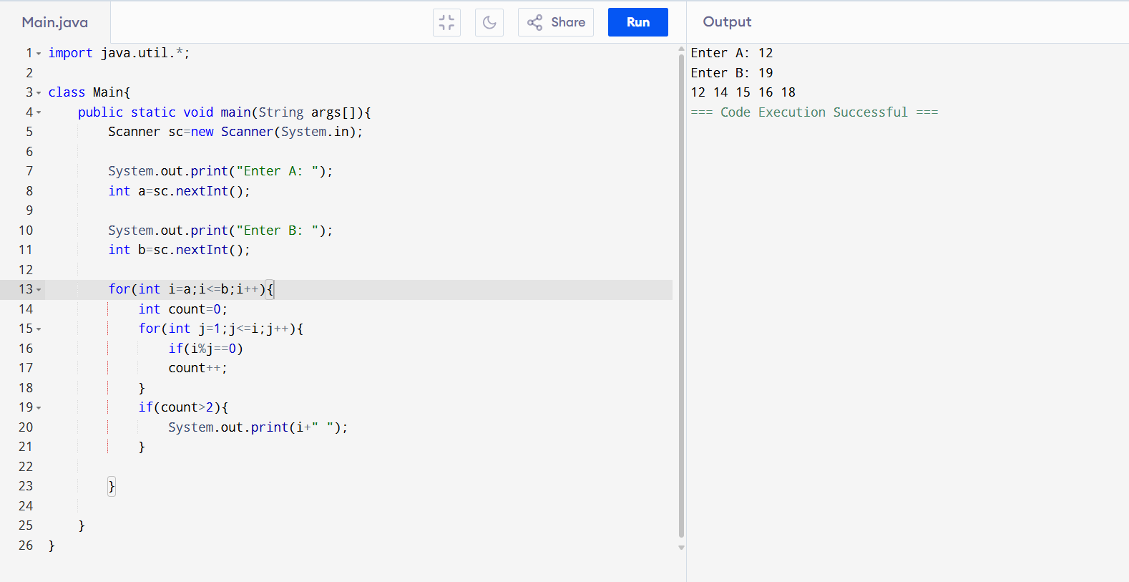

37. Factorial of N

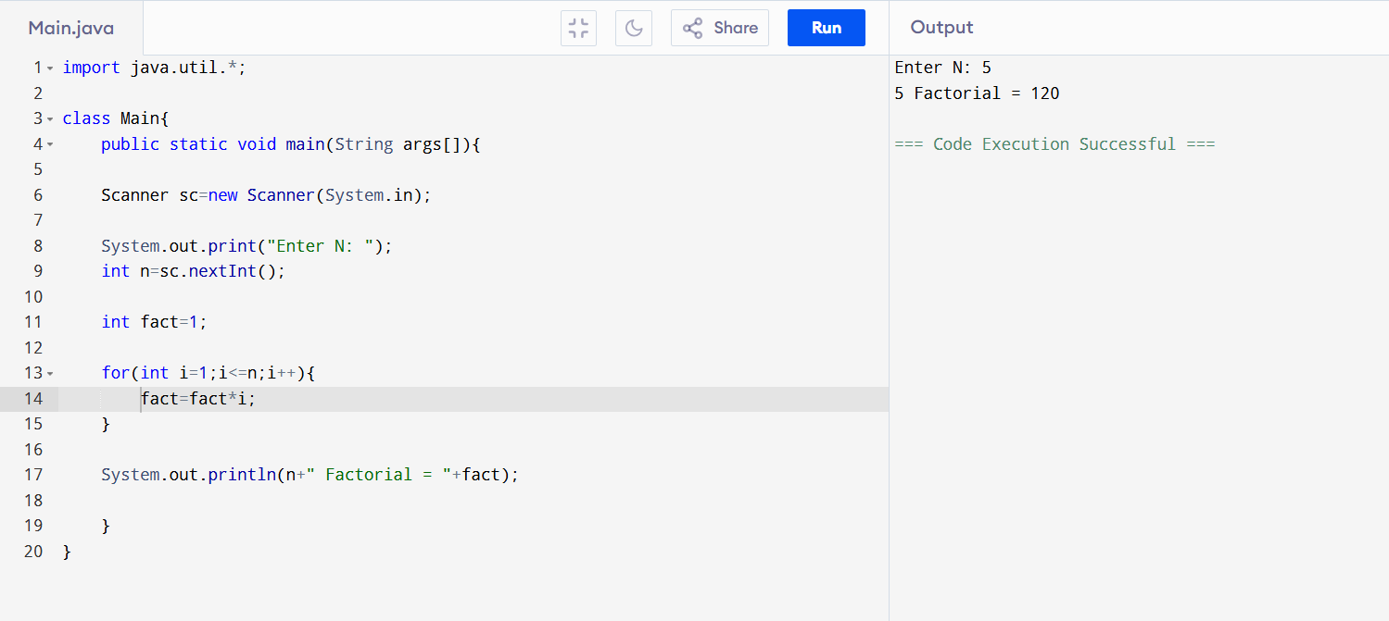

38. Leap Year Program

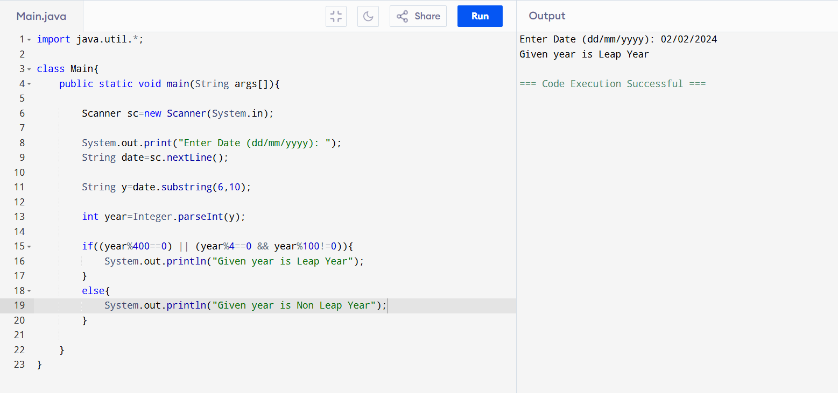

39. Number of Factors of a Number

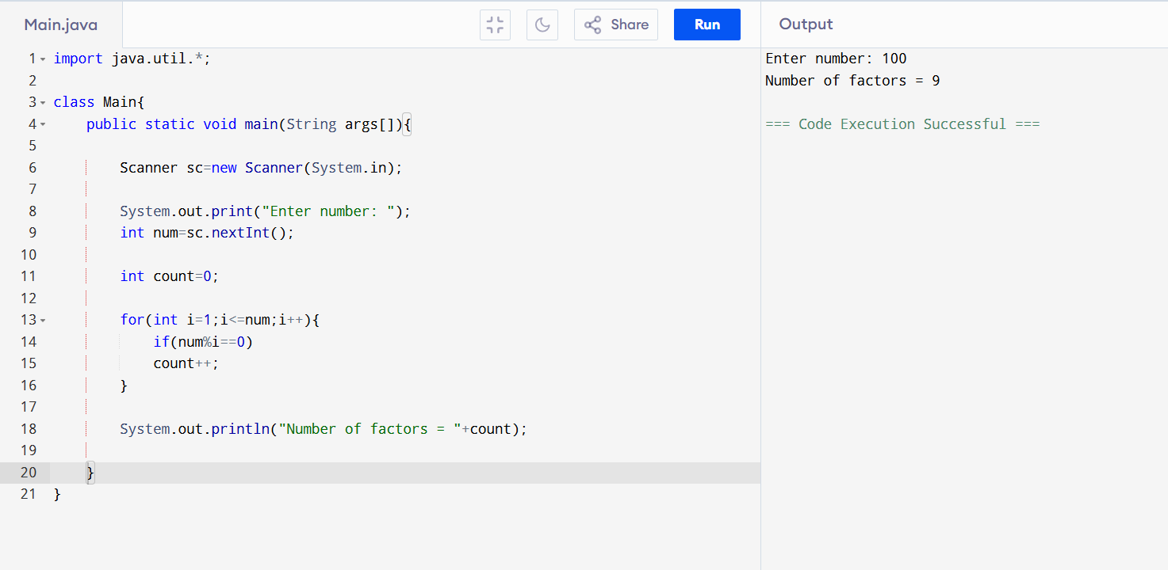

40. Perfect Number Program

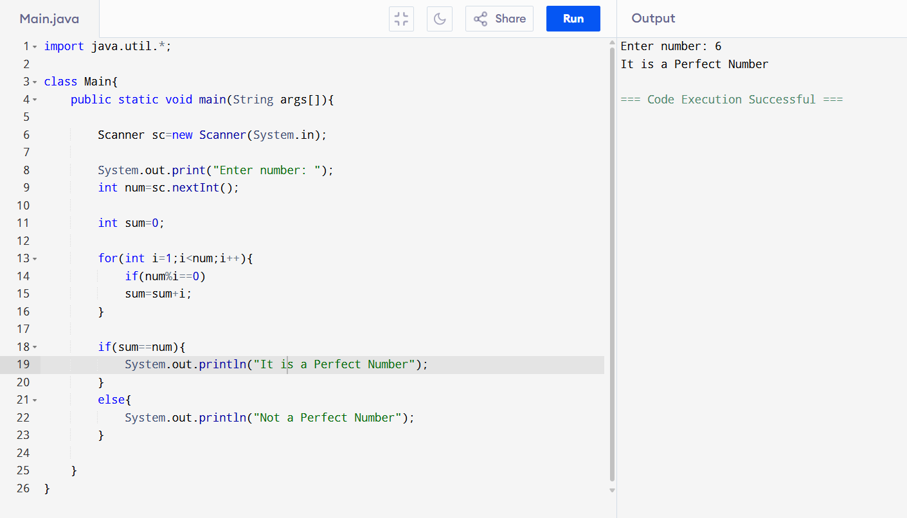

41. Square and Cube of a Decimal Number

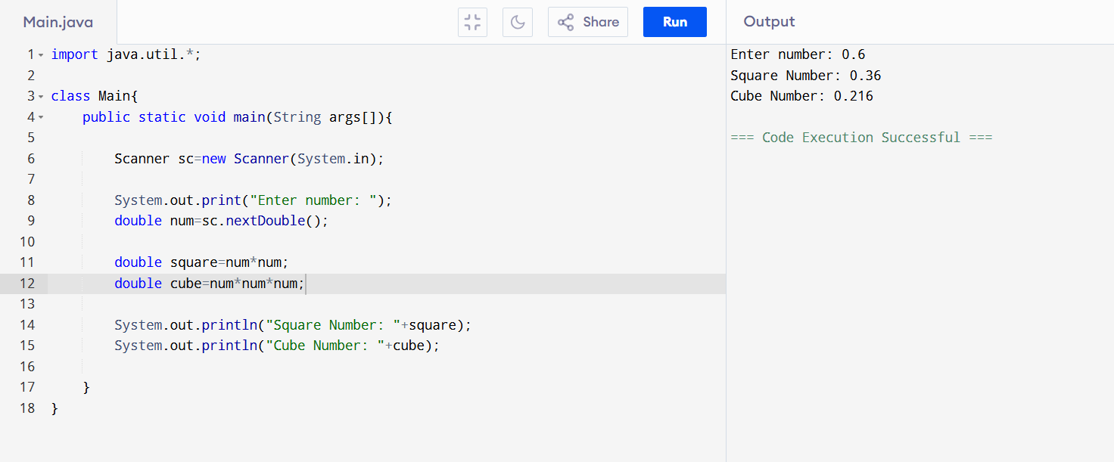

42. Find Nth Odd Numbers

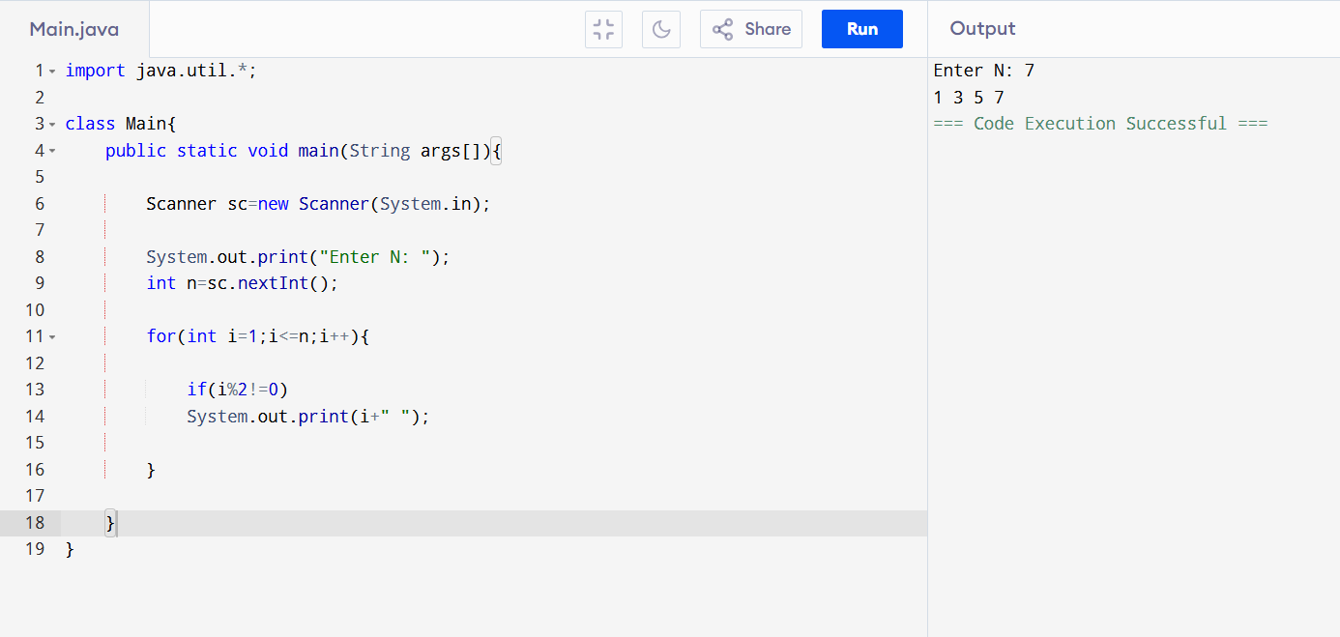

43. Armstrong Number Program

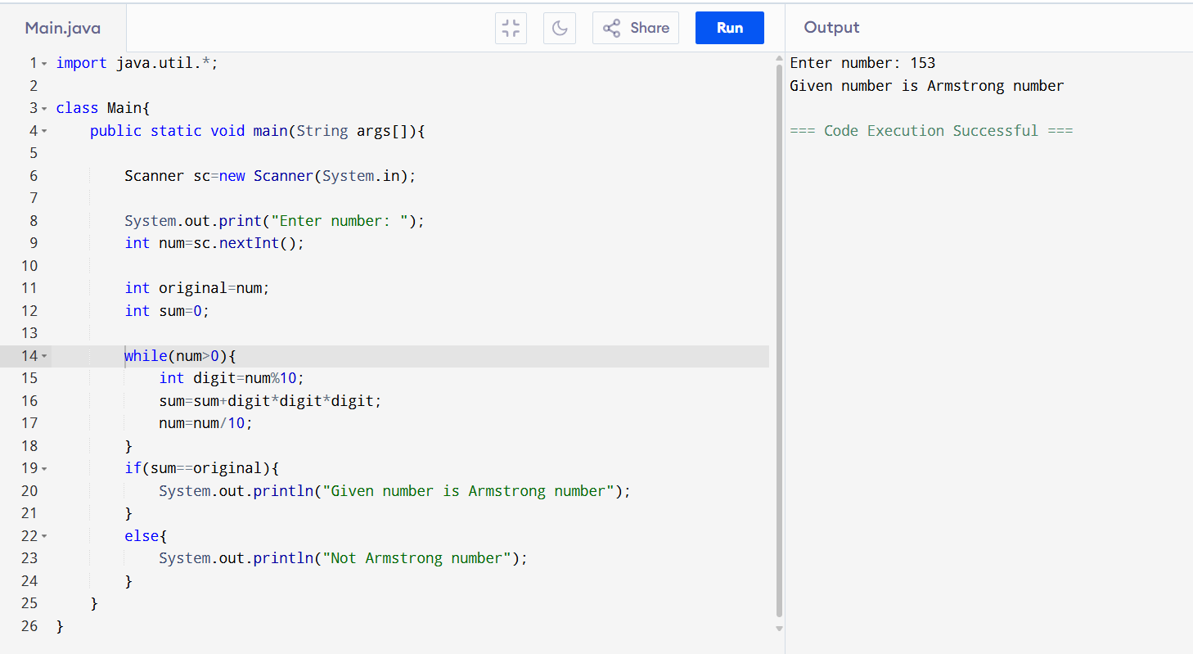

44. Sum of Digits until Single Digit

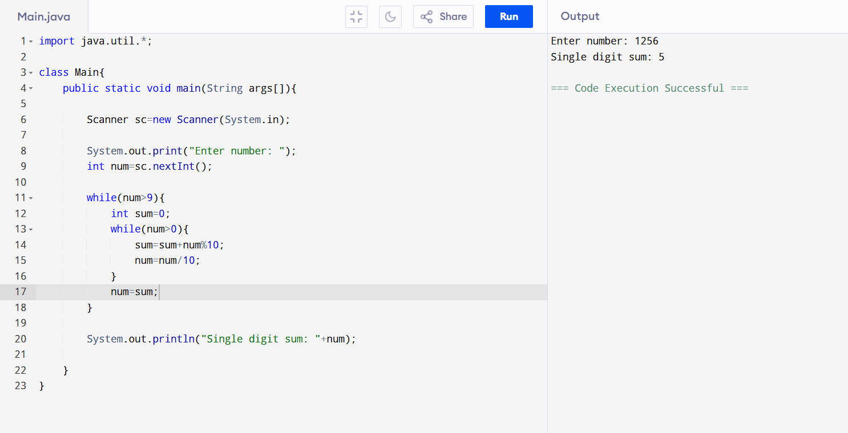

45. Square Root of Perfect Square

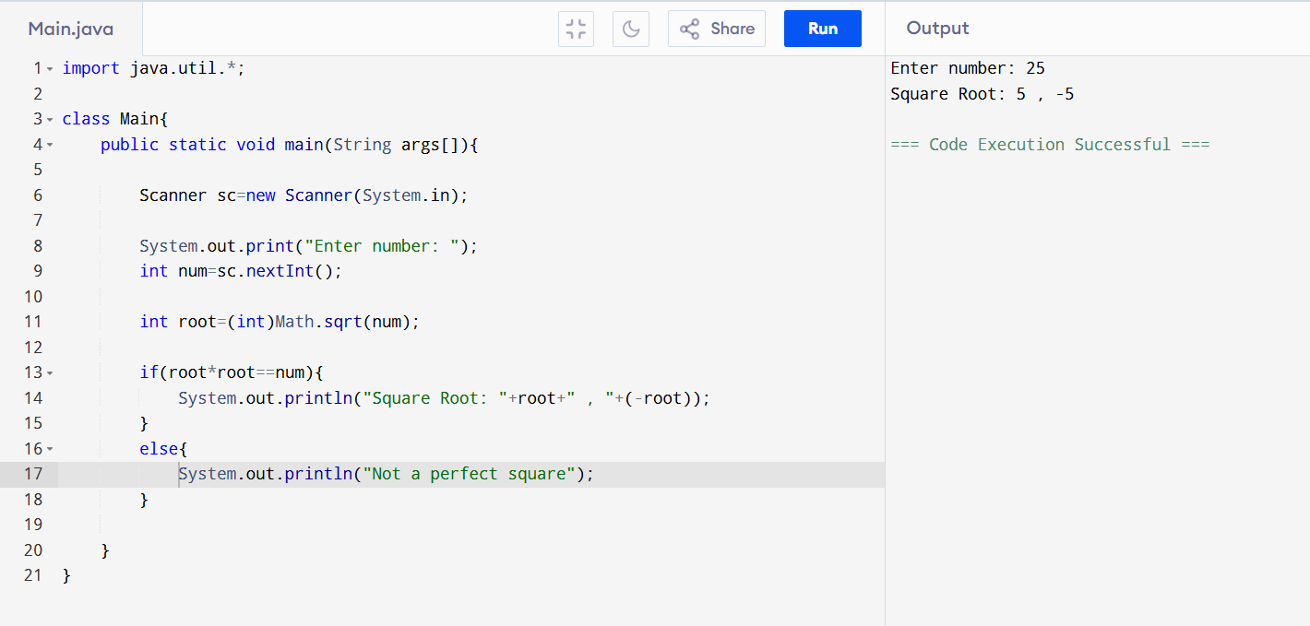

46. Check Power of Three

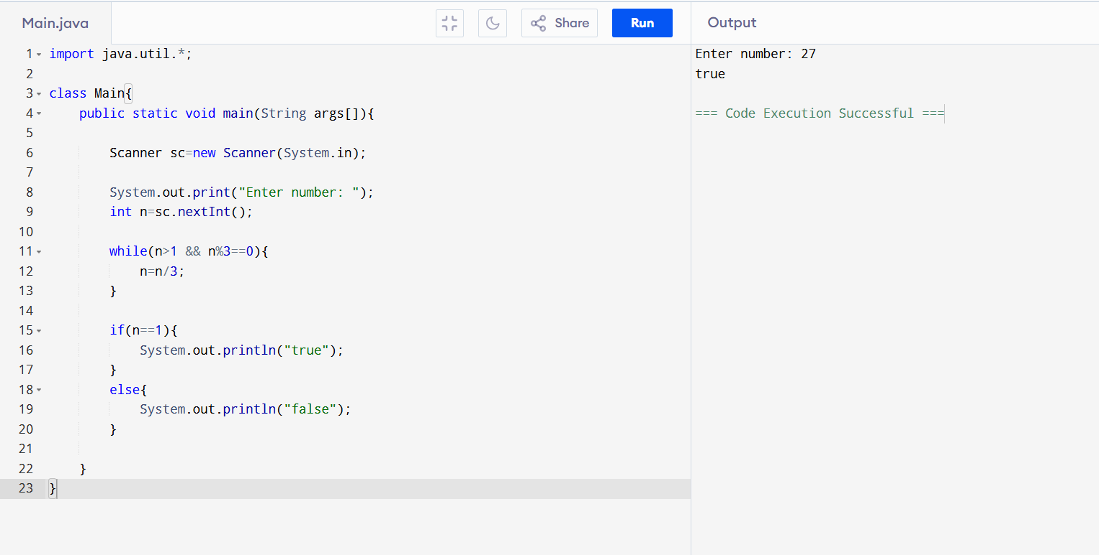

47. Most Frequent Word

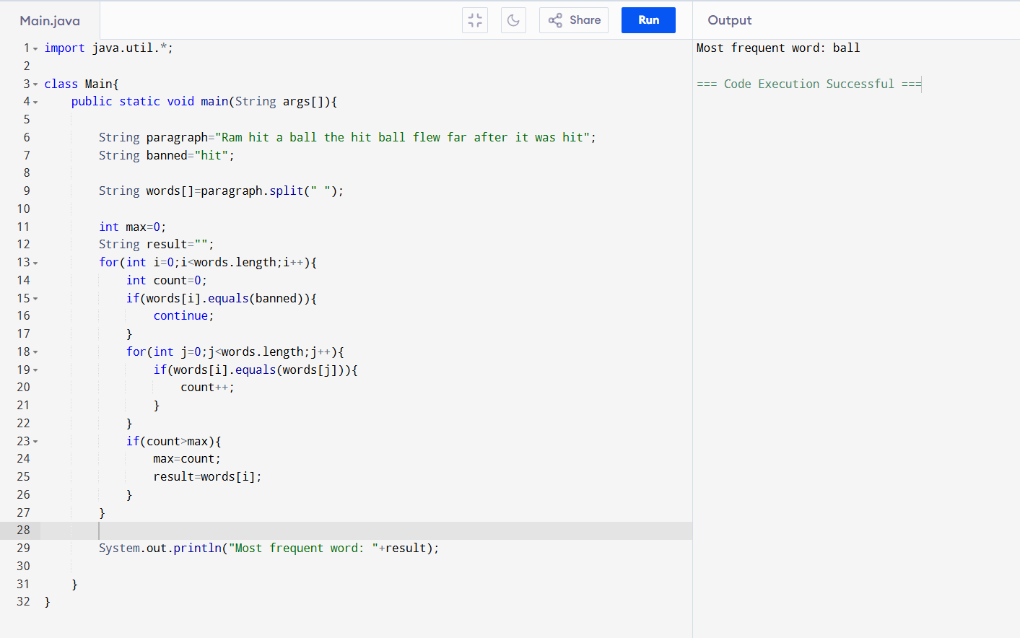

48. Duplicate Zeros in Array

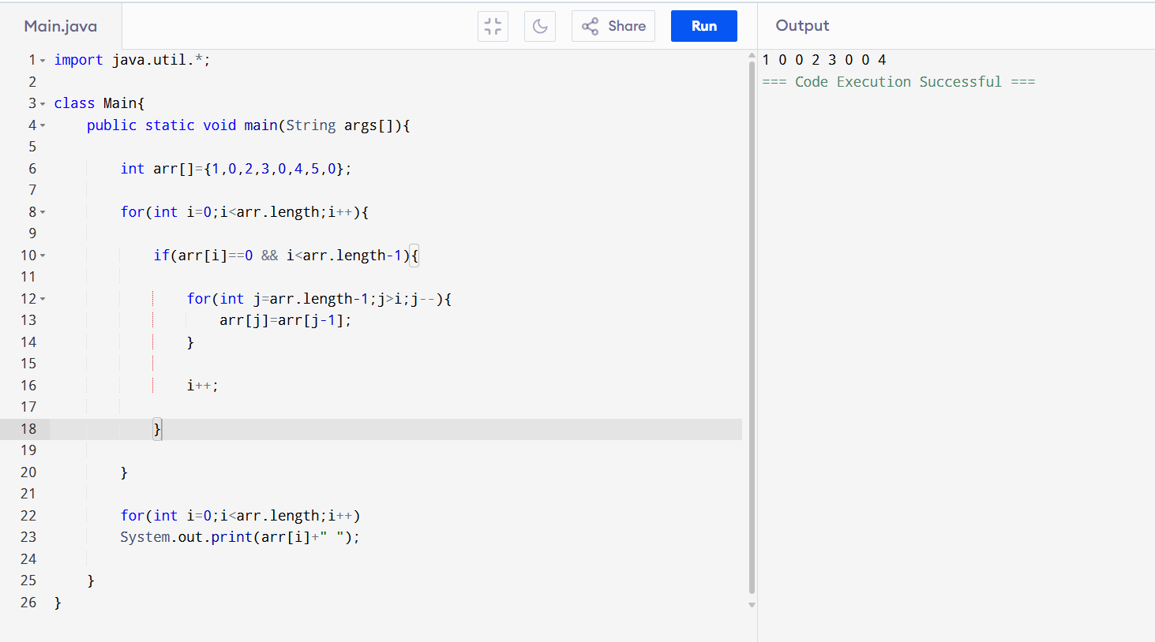

49. Find Missing Number in Array

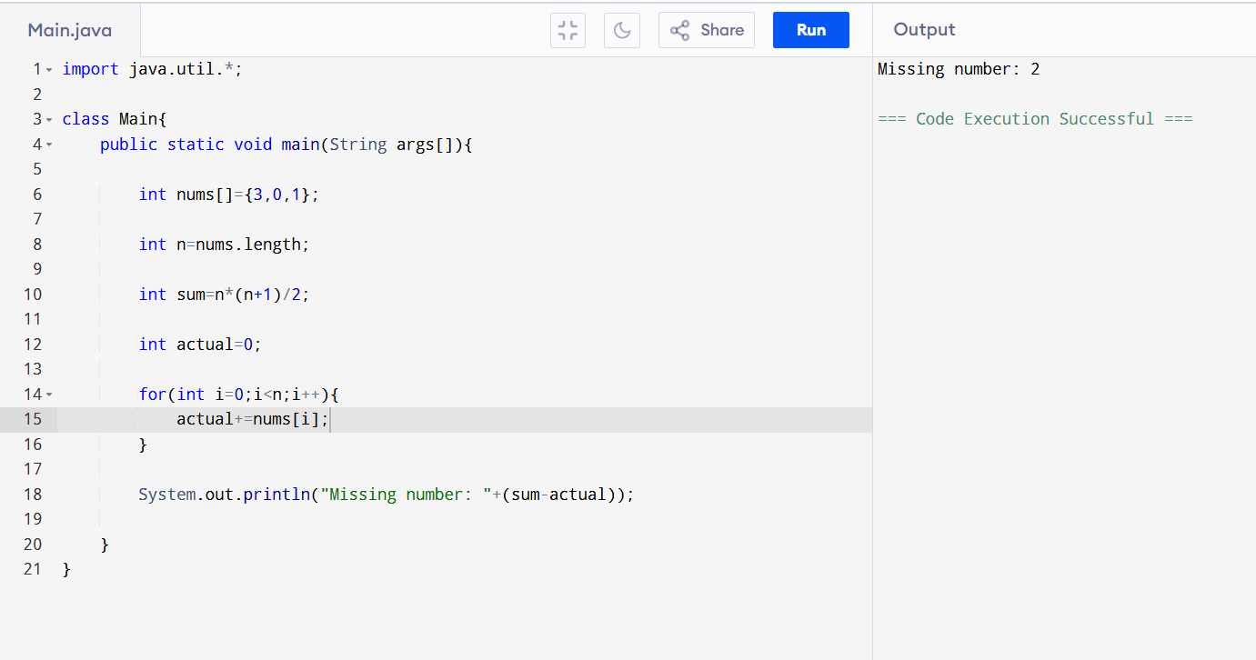

50. Maximum Subarray Sum

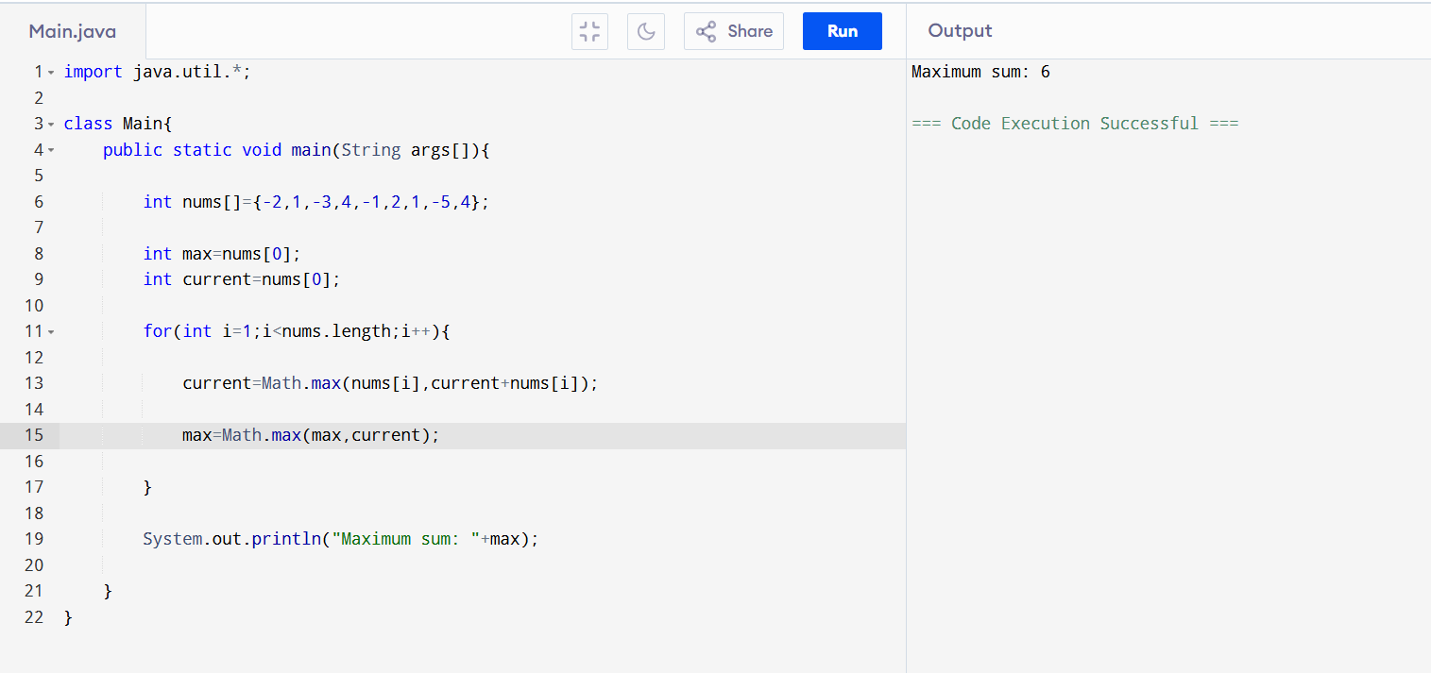

51. Multiplication Table

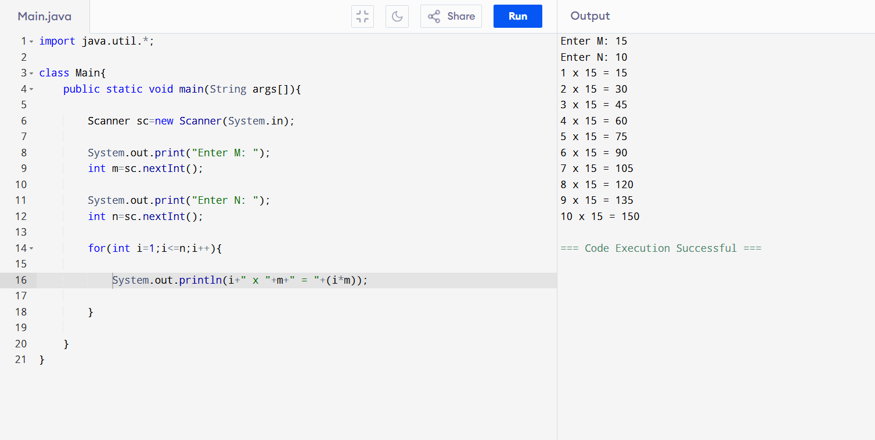

52. Multithreading with Join and Sleep

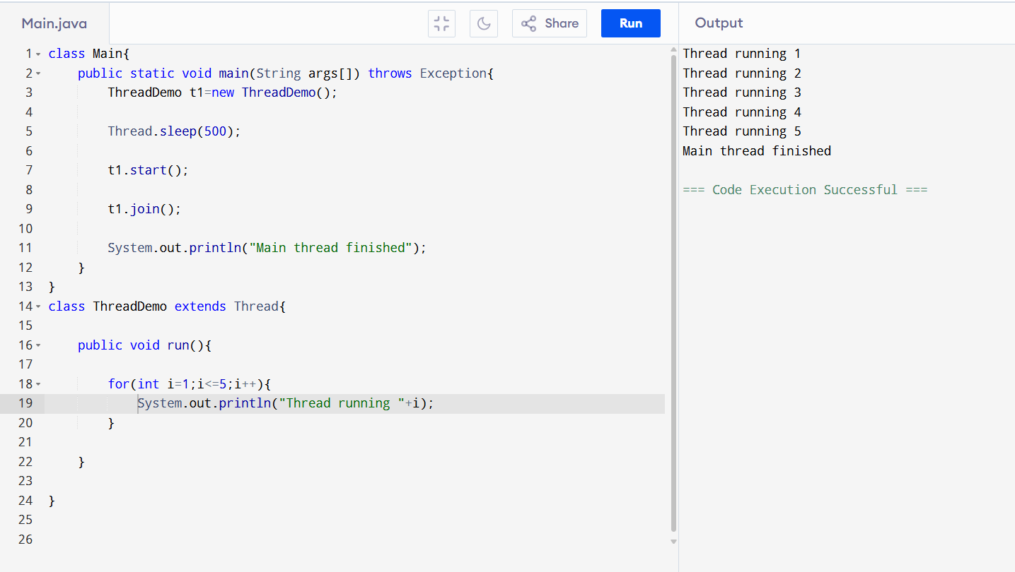

53. Menu Driven Program (do-while)

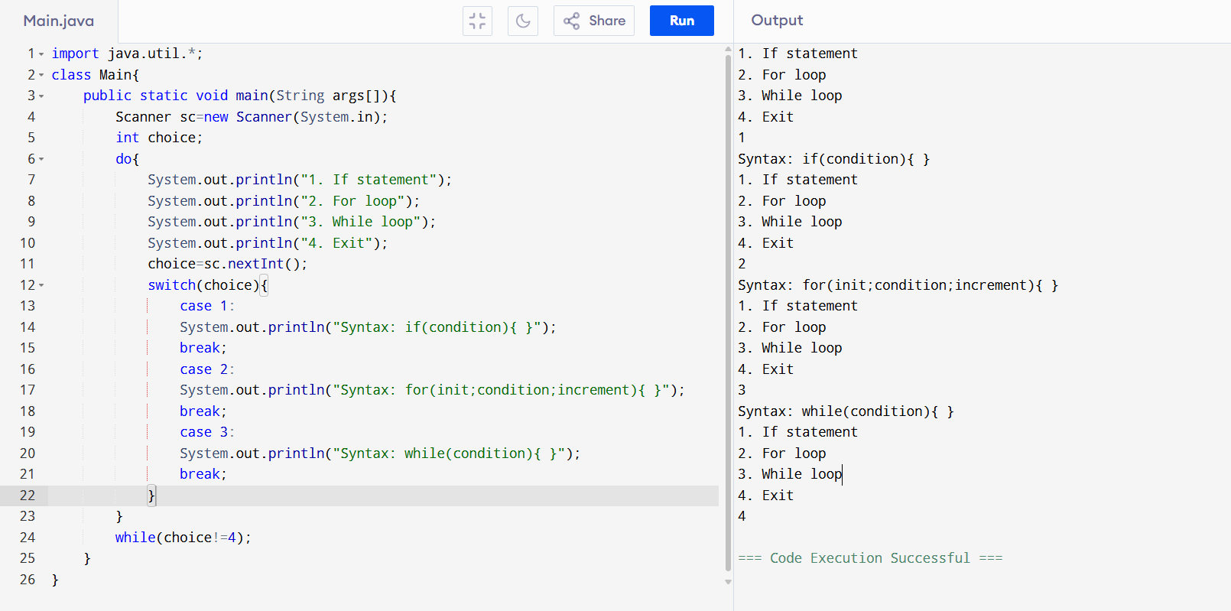

54. Generic Class for Sorting

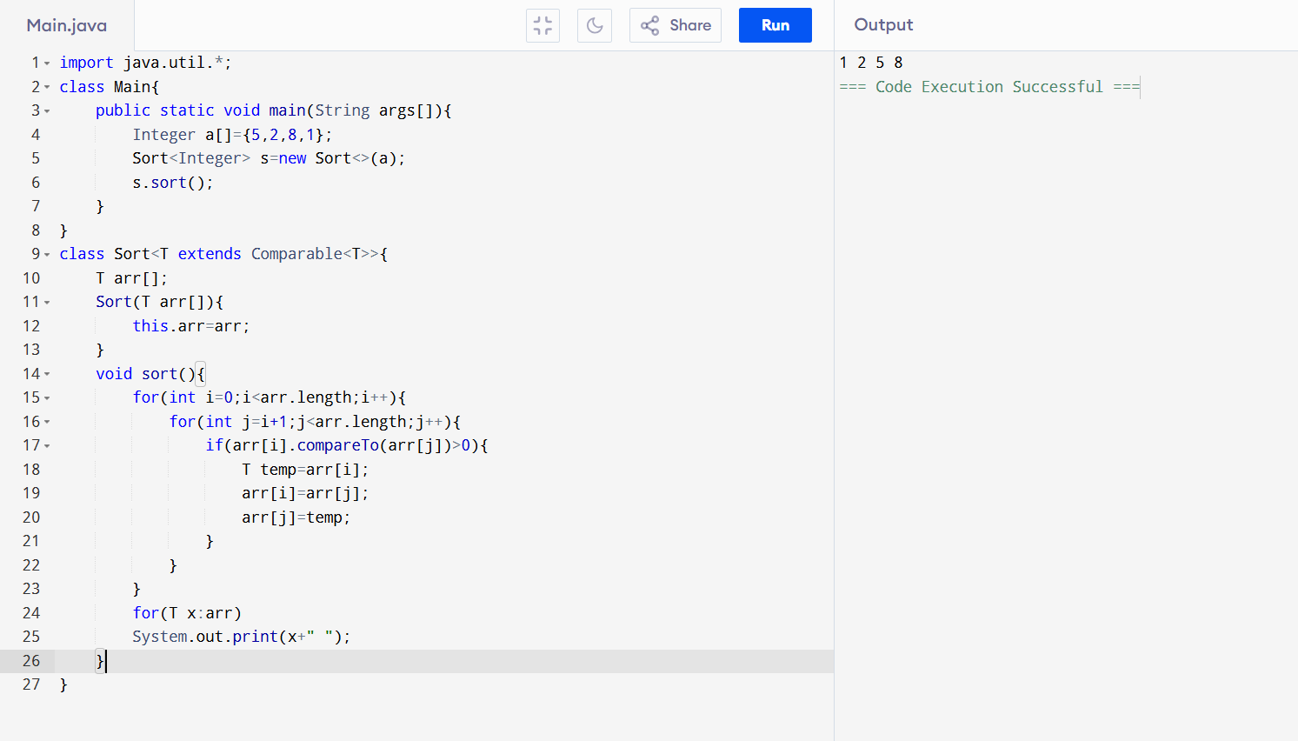

55. Function Overloading

